

SMART Teams
Exploring the
Molecular World


NS1 Power Switch for Cell Receptors
Working to Understand NS1’s capabilities
DC. Everest SMART team project 2009-2010
Mentors: Dr. Michael Patrick
Dr. Tim Herman
Advisor: Bill Heeren
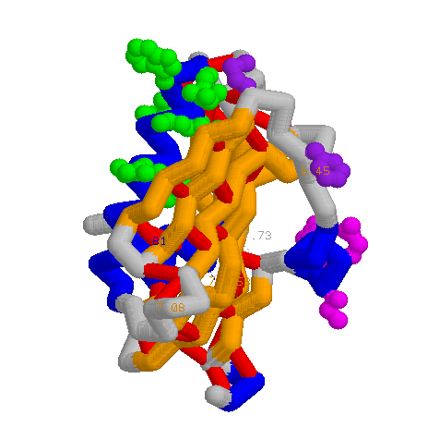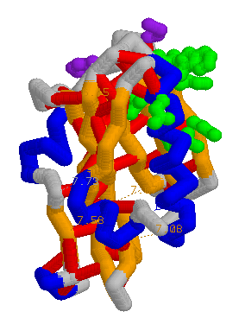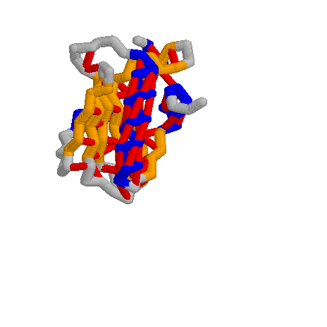
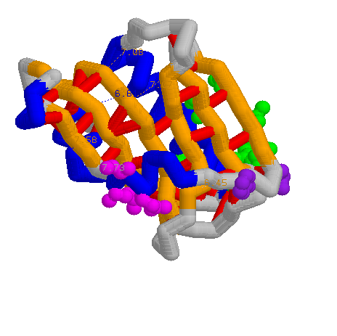

PDB files: 3EE9
Primary Citations: Structure of NS1A effector domain from the influenza A/Udorn/72 virus
Xia, S., Monzingo, A.F., Robertus, J.D.
(2009) Acta Crystallogr.,Sect.D 65: 11-17
Format: Alpha carbon backbone

Description: NS1 is an influenza protein that was just recently discovered. It shuts down receptors that provide security against contaminates. These receptors are what distinguish between foreign bodies. The receptor is called Trim25. Trim25 has a hydrophobic area on it, which is the receptor. The virus shuts down the receptor by splitting the two dimers (or halves) apart (at the amino acids, colored purple) and inserts a hydrophobic area (colored green) into another hydrophobic part of the receptor and this is how it makes it so your immune system is basically blind and can’t tell what is good and what is bad. By modeling this we are hoping to find a way to shut down this part of the cell before it can shut us down. It is in the H5N1 and H1N1 viruses and this is one of the ways that it is so devastating on the body.
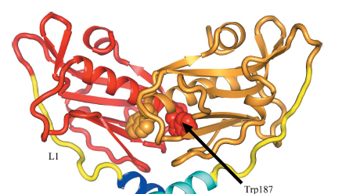
Specific Model Information:
Blue- Alpha Helix
Red- Hydrogen Bonds
Orange- beta sheets
Green- Hydrophobic area that takes over RNA production of host cells allowing NS1 to produce viral DNA
Purple- Amino acids that let the NS1 dimer split into two parts
From MSOE 3EE9 primary citation shows 3EE9 dimers

Magenta-Other amino acids that shut down “security cameras” receptors

