

SMART Teams
Exploring the
Molecular World
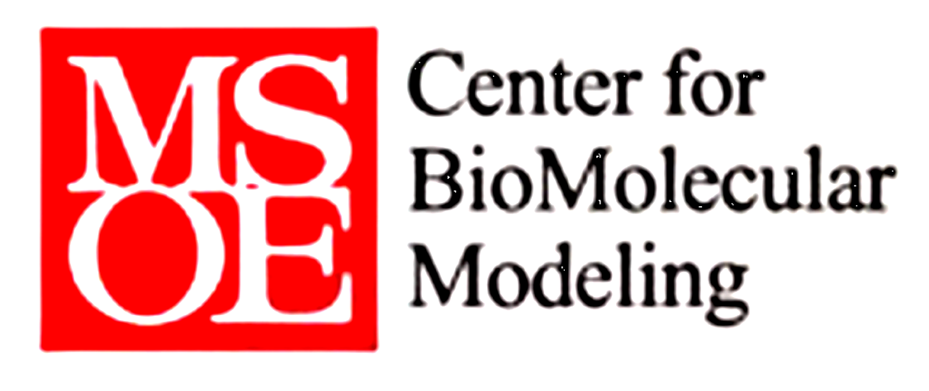

Proteins: The Basic Building Blocks of Life Protein Organization
Modeling the NS1 Effector Binding Site of the Influenza Virus
Working to Understand how Proteins Defeat Viral Infections
DC. Everest SMART team project 2009-2010
Lucas Dahlke, Tyler Ebert, Jordan Kappel, Trevor Kraeger, Jeff Marquardt, Tyler Stokka, Kyle Schwan
Mentors: Dr. Shannon Colton
Advisor: Bill Heeren

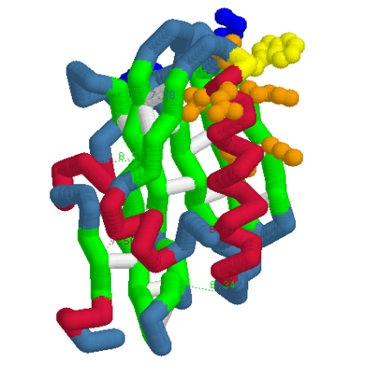

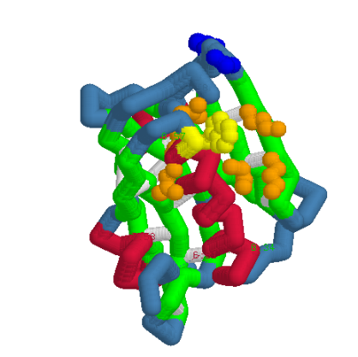

PDB files: 3EE9
Primary Citations: Structure of NS1A effector domain from the
influenza A/Udorn/72 virus (put in the names of the people as well as the journal article date…. In the right fashion.
Format: Alpha carbon backbone
RP: Zcorp with plaster

Description: There are many diseases that are out in the world that do not have any cure/vaccine at all whatsoever. Scientists are working very hard so that there is a powerful vaccination that would be able to cure these viral diseases, and eventually will. However, for the time being these diseases are taken out by something that is more powerful than any vaccine or medication; this substance is the NS1 protein, made entirely out of amino acid chains.

When a virus enters the human bloodstream, there is a protein called TRIM 25 that is like a high- tech virus detection system. This system detects a virus through the little indents it has that act as receptacles. However, just like every type of security system, there is a flaw. The flaw for TRIM 25 is the fact that a viral molecule has little prongs that can go into these receptacles and plug up the protein. This basically shuts down the system and can spread throughout the body shutting down more and more proteins that are like this. It is like hacking a computer where once a hacker gets passed the firewalls, he/she can shutdown and control everything on that computer file. Now, scientists are also researching on how to make the TRIM 25 not have these “receptacles,” or find a virus that does not have these prongs on them that would shut down these very important security defenses.

Specific Model Information:
Yellow and Orange Spheres…hydrophobic “prongs” that plug into the TRIM 25.
Blue Spheres…these basically refer to a couple of different amino acids
Red Helix… right handed helix
Lime Green region… beta sheets linked by hydrogen bonds.
Offset Blue… shows amino acid chains.

