Title: Human Protein Disulfide Isomerase
SMART Teams
Exploring the
Molecular World

Author: Zachary Bluestein
Teacher: Bill Heeren
Sponsor: Dr. Shannon Colton
School: D.C. Everest Senior High School
6500 Alderson Street
Weston, Wisconsin 54476
Color Guide

Dark green- Alpha helices
Light green- Beta sheets
Light purple – hydrogen bonds
Dark red – disulfide bonds
Yellow – Residues that cleave the disulfide bond
Orange – residues that participate in the redox reaction

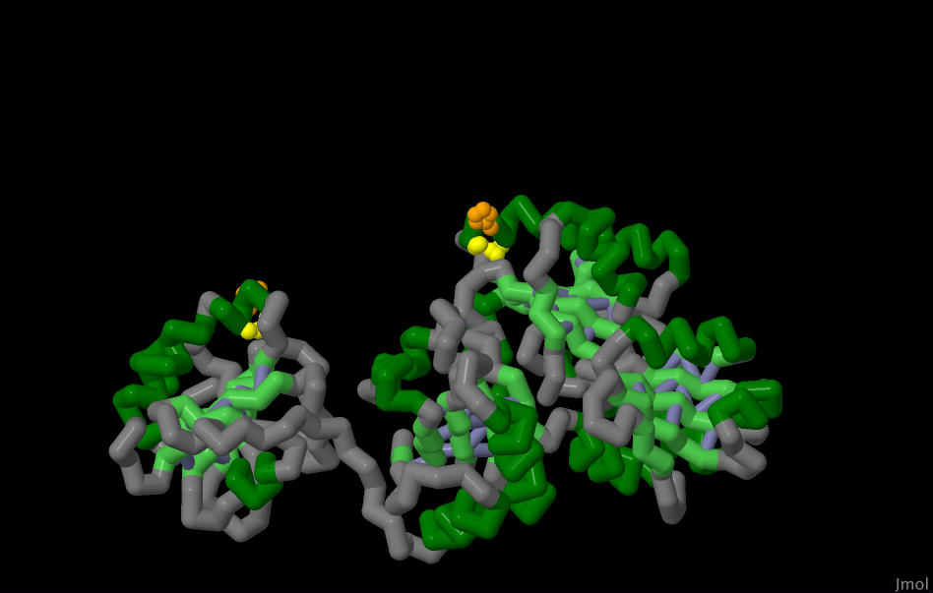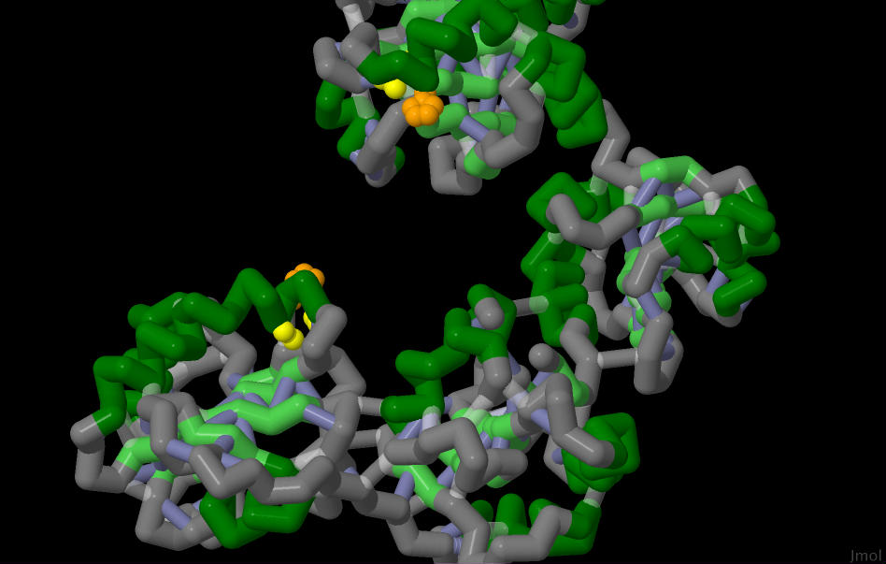

To get inside the cell, residues on the B chain of Ricin bond to carbohydrates on the outside of the cell. Before the A chain (the chain which destroys ribosomes) can enter the cell, a single disulfide bond connecting the two chains must be cleaved. The enzyme which does this is Human Protein Disulfide Isomerase, or HDPI. The residues which cleave this bond, cysteines 397, 400, 53, and 56, are shown in yellow.

HPDI comes in two configurations: oxidized and reduced. The oxidized version is shown on the left and the reduced form is shown on the right. In the oxidized form, the distance between the active sites is around 40 Angstroms, but in the reduced form, this distance shrinks to 27 Angstroms. The oxidized form, as a result, has a more open hydrophobic core where subtrates can enter, and the rate of reaction increases.

