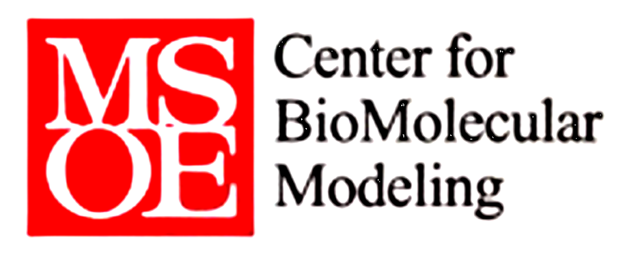

SMART Teams
Exploring the
Molecular World
DC. Everest SMART Team Project 2012-2013
Author: Alexis Abrego
Mentor: Dr. Shannon Colton
Advisor: Bill Heeren

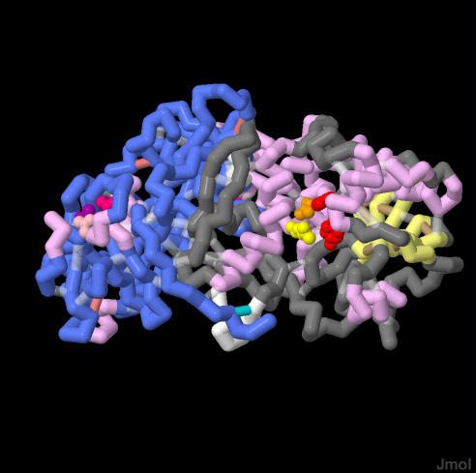 Legend
B chain-baby blue [96,128, 255]
A chain – grey
Terminal end- white
Sheet- light yellow [255,255,128]
Helix- rose [255, 192,255]
H-bonds – light brown [190,160,110]
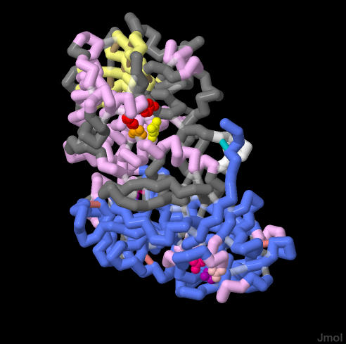Tyr 80, 123- red
Glu 177 – orange
Arg 180 – yellow
Ssbonds - Indian red [240,128,128]
Ssbond between chain A and B – teal [0,206,209]
Asp 22 and 234 - bright purple [176, 0,176]
Gln 47 and 256 - bubble gum pink [255, 0,128]
Asn 46 and 255 - coral [255,192,200]

September 7, 1978 Georgi Markovi walked across the Waterloo Bridge on his way to the bus stop. It was crowded and as he reached his destination he felt a sharp poke to his back right thigh. He turned back and saw a man pick up a fallen umbrella. Shortly thereafter he saw a small red pimple formed at the site where he was poked. Three days later Markovi died and the plant toxin Ricin was written into the history textbooks implicated with the now nicknamed “Umbrella Murder.” This deadly toxin derived from the Castor Bean enters the cell and destroys ribosomes rendering the cell incapable of protein production resulting in cell death being fatal to the host body. This process occurs in three major steps: entering the cell, modification in the endoplasmic reticulum, and entrance into the cytosol beginning ribosomal destruction.

There are two parts to the construction of Ricin: the A-chain and subsequently the B-chain. The A-chain is where the inactivation of ribosomes occurs and the B-chain is what gets the foreign molecule into the cell and keeps it inactive thus neutral in while housed in the Castor Bean. The B-chain has attached to it several residues (Asp 22 & 234, Gln 47& 256, Asn 46 & 255) that attach to any one of the myriad of galactolipids and glycoproteins on the cell surface. Asp 22 and 234 make the primary interaction with the galactolipids or glycoproteins while the other residues secure and strengthen the bonds to said molecules on the cell surface. Through receptor mediated endocytosis the Ricin makes its way into the cell and to the Golgi only about 4% of Ricin molecules make it to this point before degradation by the cell. After traveling through the Golgi apparatus the Ricin molecules are transported to the Endoplasmic Reticulum.

Though the actual location in the cell when the toxin is translocated is unknown the most likely option for such actions is the ER for it is equipped with many chaperonin to mediate protein change and enzyme substrates to molecularly change proteins. In the case of Ricin the major change that needs to occur to activate the toxin is to break the disulfide bond between the A and the B chain. This task is most likely completed by protein disulphide isomerase breaking that fatal bond allowing Ricin to go to work once transported to the cytosol.

When the A-chain of Ricin is set loose in the cytosol it targets a specific adenine in the ribosome. This adenine at position 4324, when tested upon a rat’s liver, was found to be conserved in the universal sequence known as the sarcin-ricin loop. (5’-AGUACGAGAGGA-3’) Following the cleaving of this adenine, the binding of elongation factors is inhibited thus halting protein growth and folding resulting in irreversibly inactivating a ribosome. This catastrophic end product is made possible by four key residues. Tyrosines 80 and 123 (red) make a stacking interaction with the adenine and Arginine 180 (yellow) protonates the leaving adenine at N-3 thus allowing electrons to flow and breaking the final bond of the N-9 to the C-1’ of the adjacent ribose. As a result of the breaking of the adenine from the ribose a oxycarbonium ion is left and is stabilized by Glutamic acid 177 (orange). The Arginine 180 completes the stabilization by taking a proton from a nearby water molecule allowing solvent attack on the oxycarbonium ion rendering the ribosome neutral. This reaction does not prevent the A-chain of Ricin from continuing further ribosomal destruction. On the contrary, every single molecule of Ricin that makes it to the cytosol is capable of destroying 1,500 ribosomes per minute thus ending a cell’s existence in nearly no time.

While the Castor Bean by itself is not harmful to ingest and is used in many medicines, perfumes, and even as a food preserver, when even one disulfide is broken the most advanced and complex system like that of the cell can topple in minutes. Life is a delicate thing riding on thousands upon millions of bonds being held together and thousands of simultaneous processes. When even one of these is blocked or even slowed down the entire system can very easily be compromised.

