Model Summary Sheet
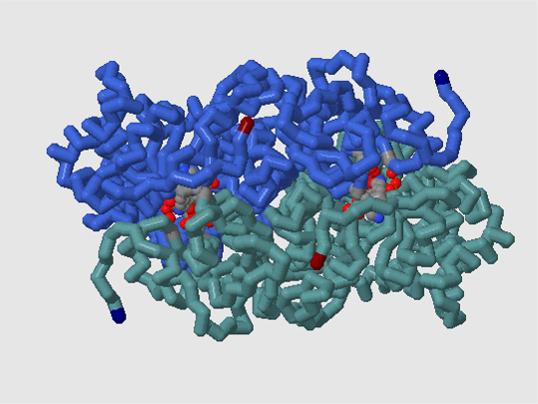
Teachers: Brenda Bott, Pat Delwiche, Joe Kinscher, JoAnn Miller
Contact person (if not ST Teacher, please provide email address):
Primary: JoAnn Miller
PDB File: 1upm
Jpg filename: 1UPM_dimer.jpg
Model Abstract:
This enzyme model highlights one large subunit dimer that is recapitulated in the hexadecameric structure. Each active site includes the activating carbamylated lysine 201 and metal ion. The ligand, 2-carboxyarabinitol-1,5-diphosphate, an RuBP analogue, is associated with each active site. The dimer model large subunits can be disconnected from each other. Each subunit features residues which interact with the ligand in the active site. Each subunit contains complementary components that complete the active site when the subunits join in an antiparallel arrangement.

What do the colors in your model indicate?
royal blue = I chain
cadetblue = b chain
cpk = ligand = RuBP analogue
lime = ligand= Ca
cpk = sidechains; lys334, lys201, asp203, glu204, thr65, glu60, lys128
dark blue = N terminus (ala9)
dark red = C terminus (val475)

Which amino acids are displayed and WHY did you display them (what is the function of these amino acids)?
lys334, lys201, asp203, glu204, thr65, glu60, lys128
These residues form the catalytic site of rubisco. The active site of rubisco must be activated prior to the introduction of the substrate RuBP. Activation requires two processes: 1) the carbamylation of a lysine residue (LYS 201) within the pocket; and 2) the addition of an Mg ²⁺ ion to the active site. The carbamylated lysine is located on the C-terminal end of one of the b-strands of the b/a barrel structure. Carbamylation stabilizes a Mg2+ ion that is crucial to the activation of the site. Once the active site has been activated, the introduction of RuBP into the active site occurs.

